U21 Pathway Academy 2022-23
The U21 Pathway Academy sits as a specific programme on our GB strand on the performance model. The aim of the U21 Pathway Academy is to start to embed the performance behaviours required to progress on our GB strand. Specifically it is looking to help our young athletes to progress to GB conversion academy, senior teams and paralympic programmes.
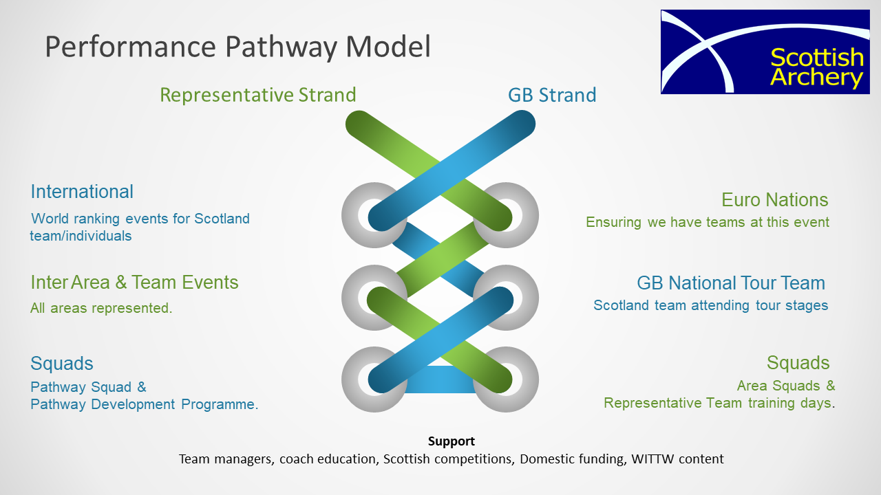

GB Strand Athletes
The GB strand is designed to provide athletes that have the desire and commitment to progress to GB teams with an opportunity to further develop themselves.
To be on the GB strand, athletes are expected to already be showing performance behaviours in line with our athlete and coach expectations and our What It Takes To Win model. This includes athletes taking ownership for their journey within the sport and having clear articulated goals along with a training plan and training diary to help them achieve them.
This programme is specifically suited to that are either new to the sport or want to become more performance focused. You might be on the representative strand but you are keen to progress onto the GB strand, again this programme will help with that transition.
If this isn’t your focus or it isn’t where you want to be, then that is ok. We have the representative strand that still allows you to represent Scotland at Home Nation and CACE type events.

Being on the Programme
We don’t have selection criteria for this programme, all we ask is that you are working with a licensed coach or you are open to doing so. If you are keen to be a part of it and have the desire and commitment to progress then we would love for you to be a part of it.
The programme itself will help you to develop the performance behaviours required to progress onto our GB strand and hopefully ultimately onto GB teams and squads.
Content wise the programme will be delivered in a hybrid model with some face to face as detailed below and remotely via short group video call sessions where we will look at topics such as:
- Training Plans
- Periodisation
- Goal setting
- Training diary
- Strength & Conditioning
- Psychology
The aim of these sessions will be to give some knowledge and then encourage the athletes to go away and work on things before coming back together to reflect and compare so they can learn from each other.
We are also keen that each athlete on the programme is working with a licensed coach within their club. If someone doesn’t have access to this then please let us know and we can look to pair keen athletes with coaches that are keen to support their development.
There will also be the opportunity to come together with the athletes on the other pathway programmes for some face to face days. There will be a charge for taking part in these days to help cover the costs, these are optional though.

Process
After completion of the application form athletes will be invited to a welcome session for the programme.
Closing date for completing the application form is Monday 3rd October at 12 noon.

Matters Not Covered
Any matters arising which are not covered within these criteria shall be dealt with by the Performance Group.

